
Iqra University
H-9 Campus Islamabad
Mid-Term Examination- Fall 2025 Semester
Course Code: CSC477 | Course Title: Data Science
Teacher’s Name: Faheem Shaukat | Total Marks: 30 (25% Weightage)
Date & Time: 04-Dec-2025 (11:00 AM to 12:30 PM) | Total Time: 90 Minutes
Student’s Name: | Registration No:

Q1 – Short Questions (Marks 2+2+3+3 = 10) — CLO1

(A) What is the main role of a data scientist? Which file system is independent of system hardware and software? Also, name the data format commonly used for web-transmitted information. (2)

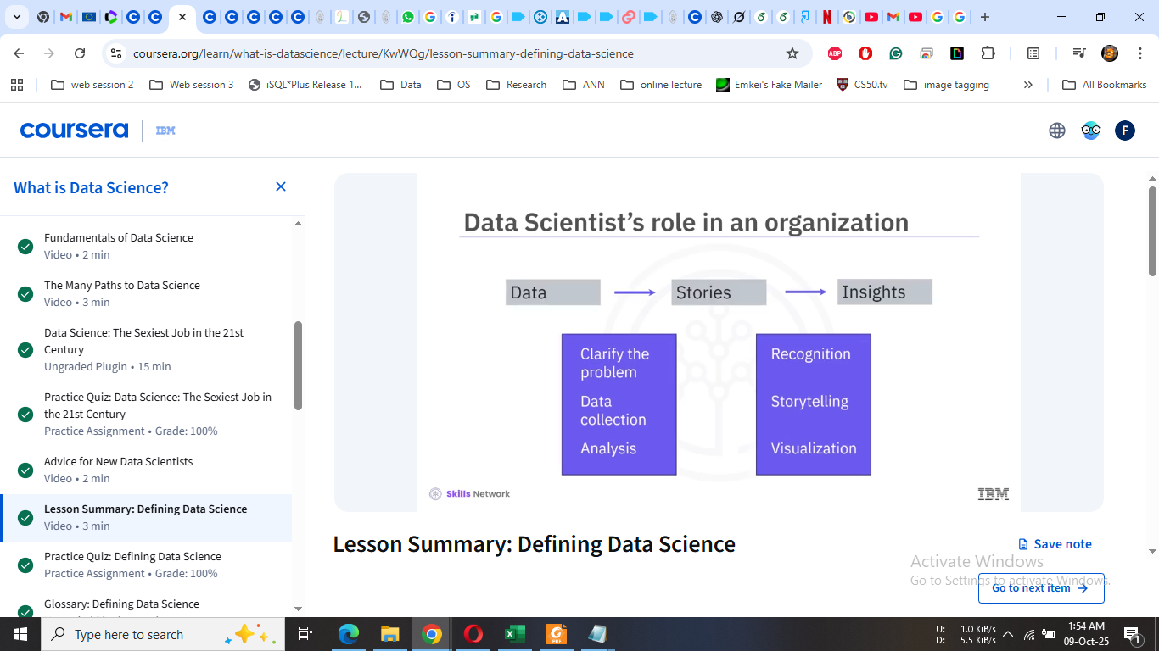

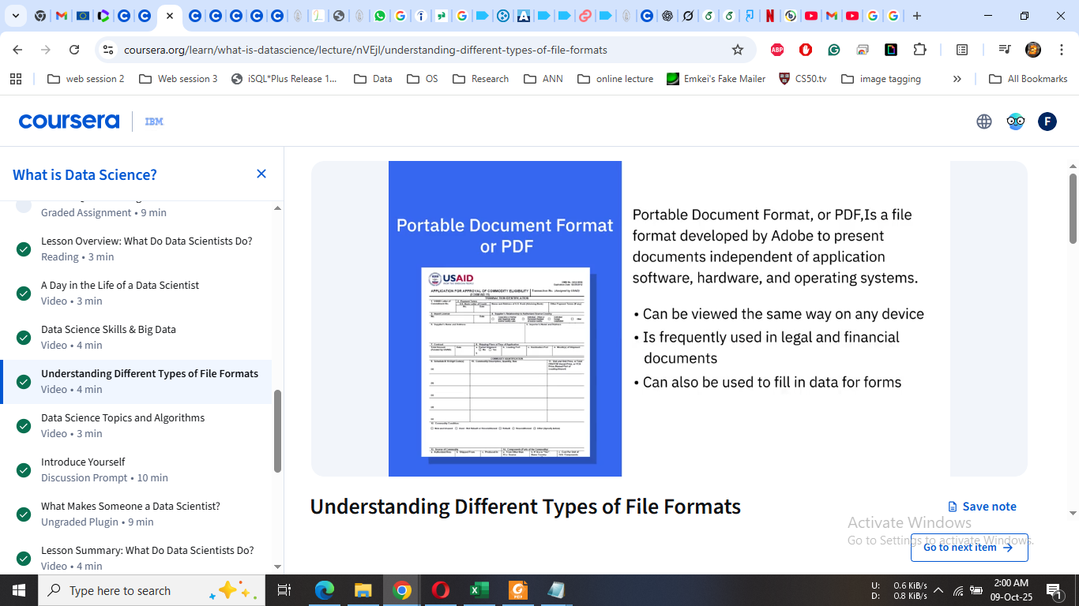

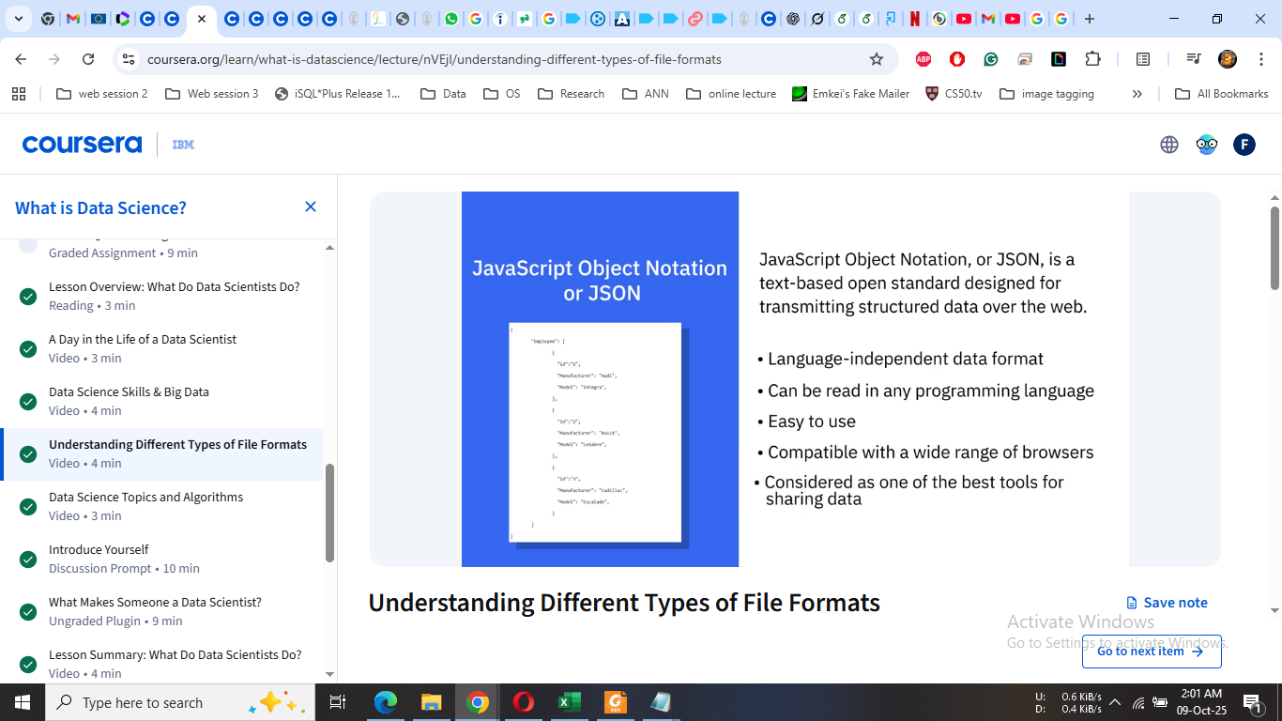

(B) List the cloud service models and cloud deployment models. Also, explain the role of cloud computing in data science. (2)



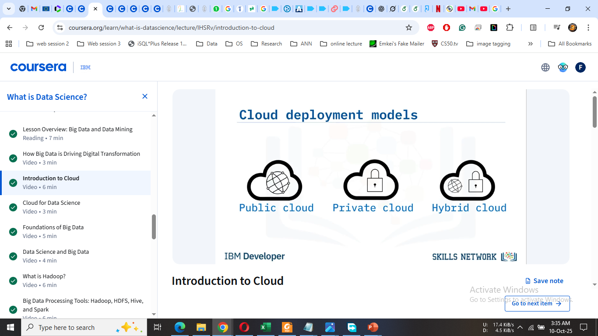



(C) What are the five V’s of Big Data? Briefly explain the uses of Hadoop and Apache Spark. (3)







(D) How can we identify the right data? How can we obtain the right data? Also define the Delphi method. (3)

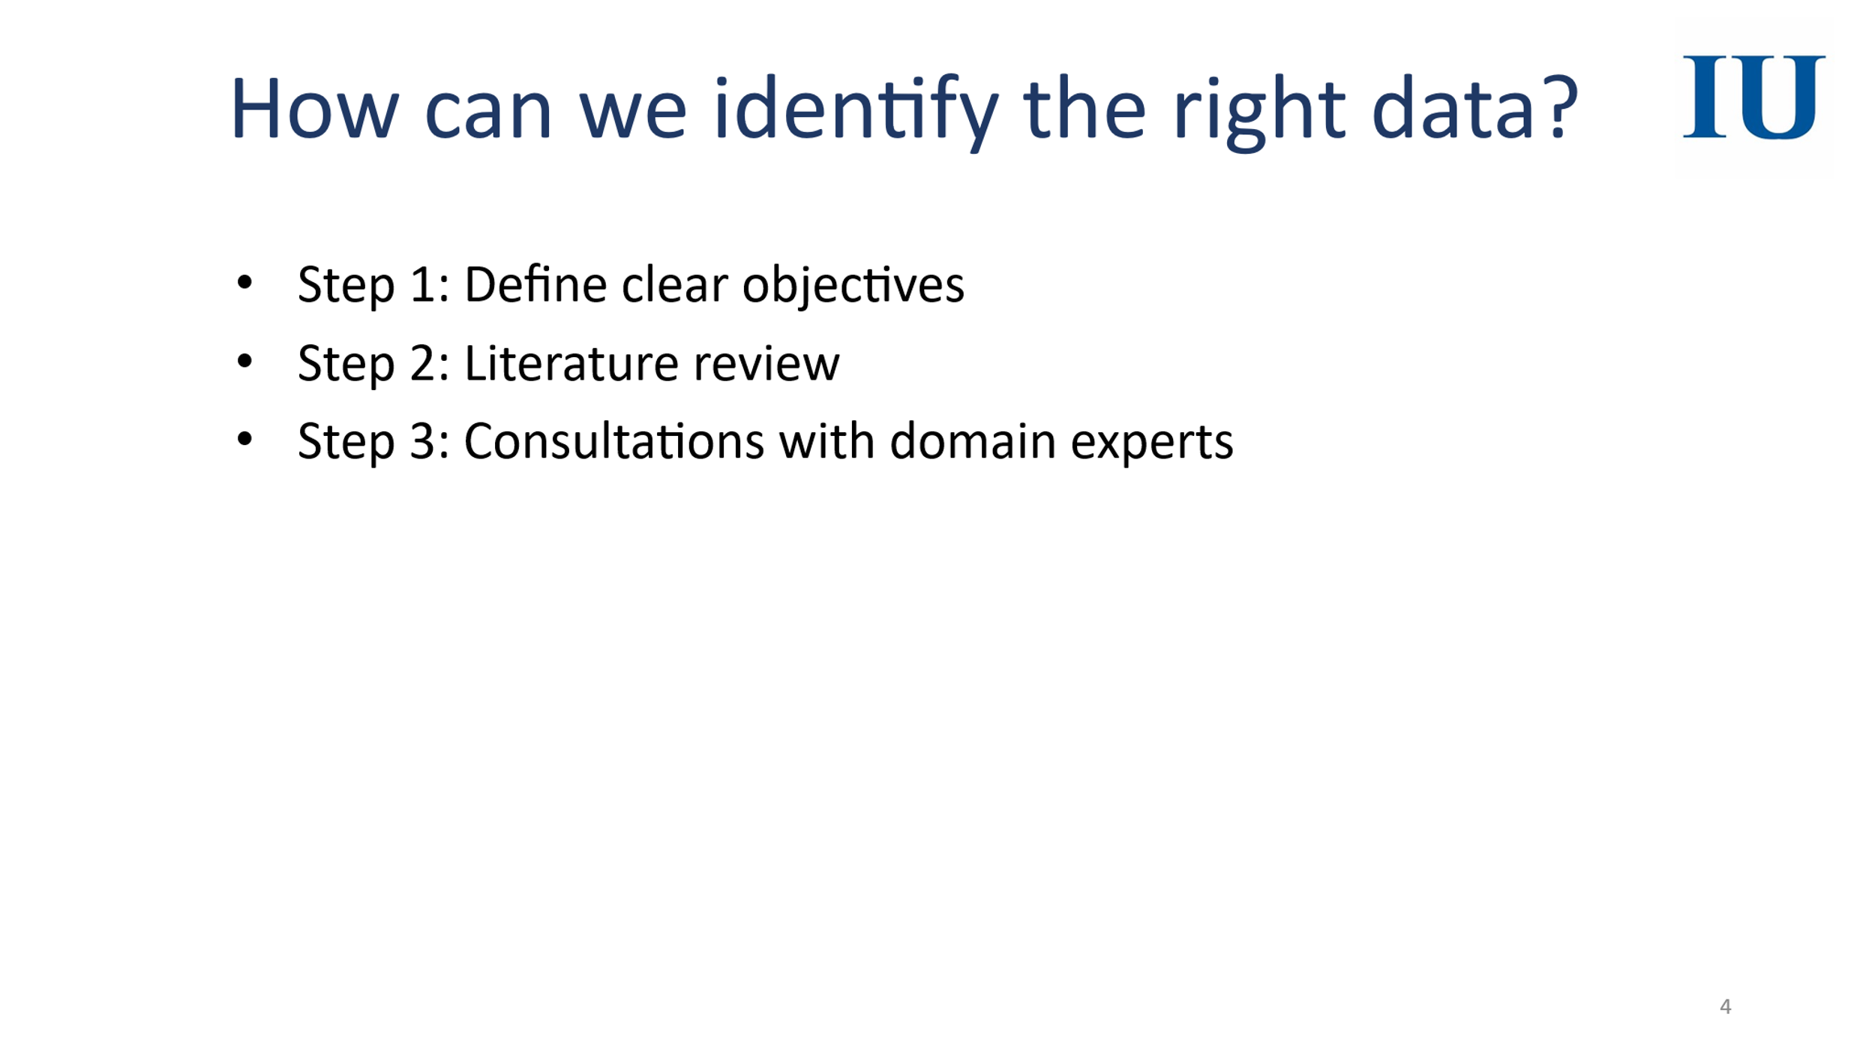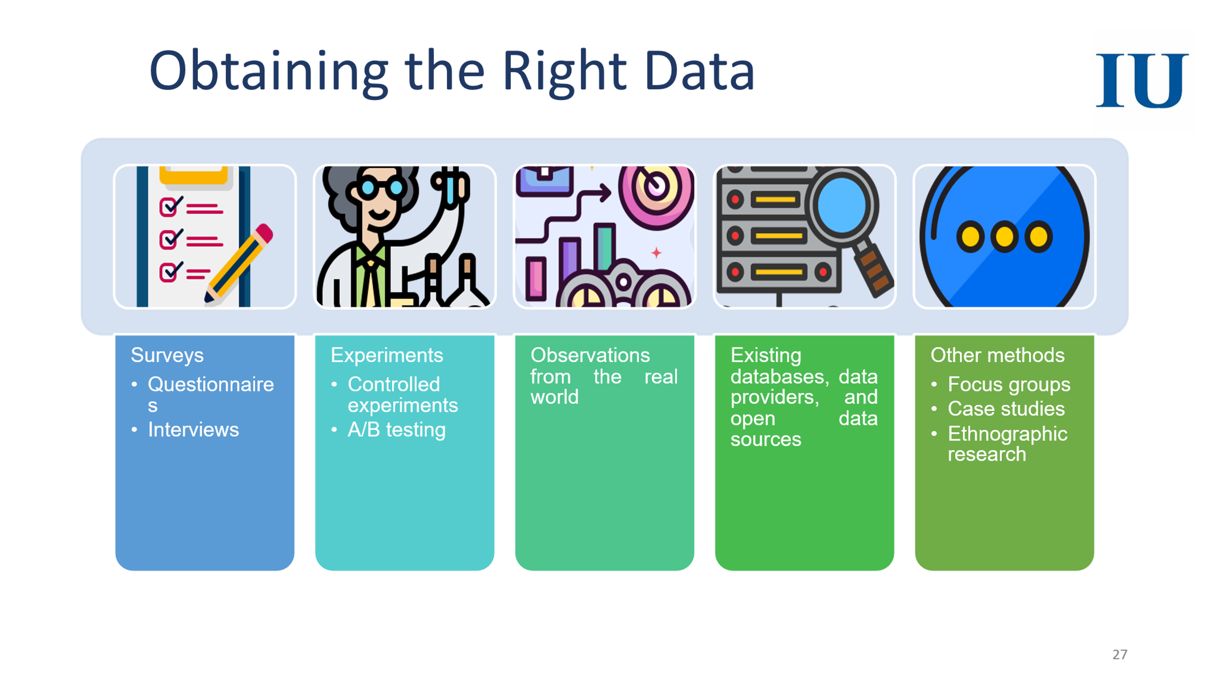

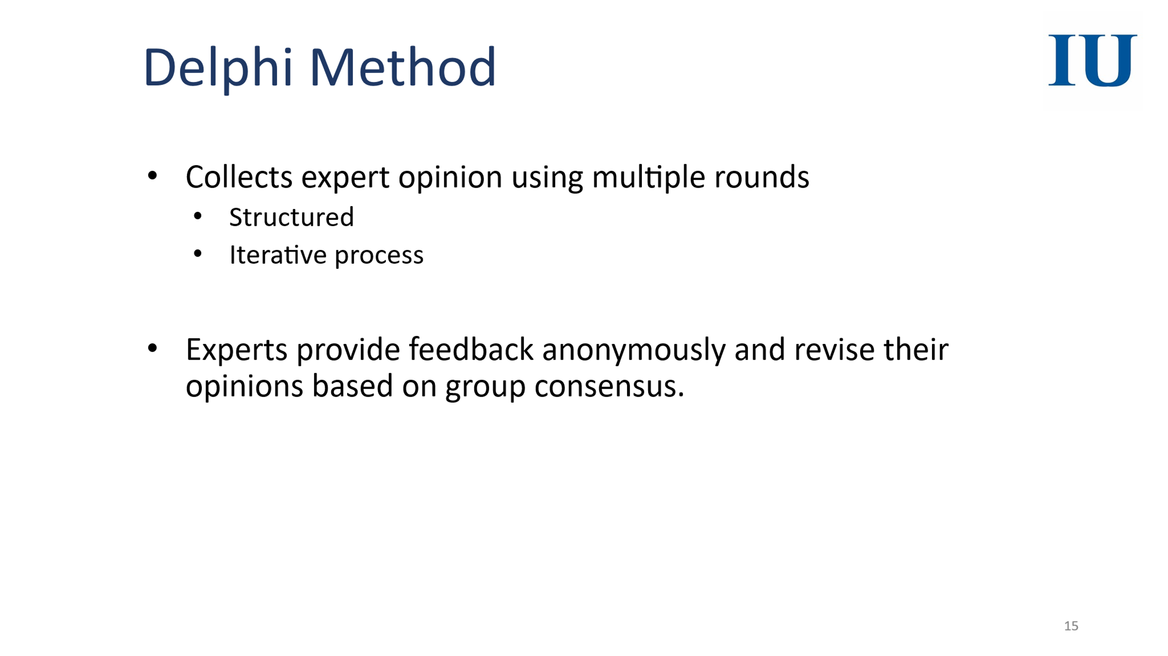

Q2 – Data Preprocessing (Marks 10) — CLO2

What is data preprocessing? Apply any three data-cleaning methods to the given dataset.
What is data reduction and data transformation? Apply one suitable data-reduction method and one data-transformation method to the dataset where appropriate.
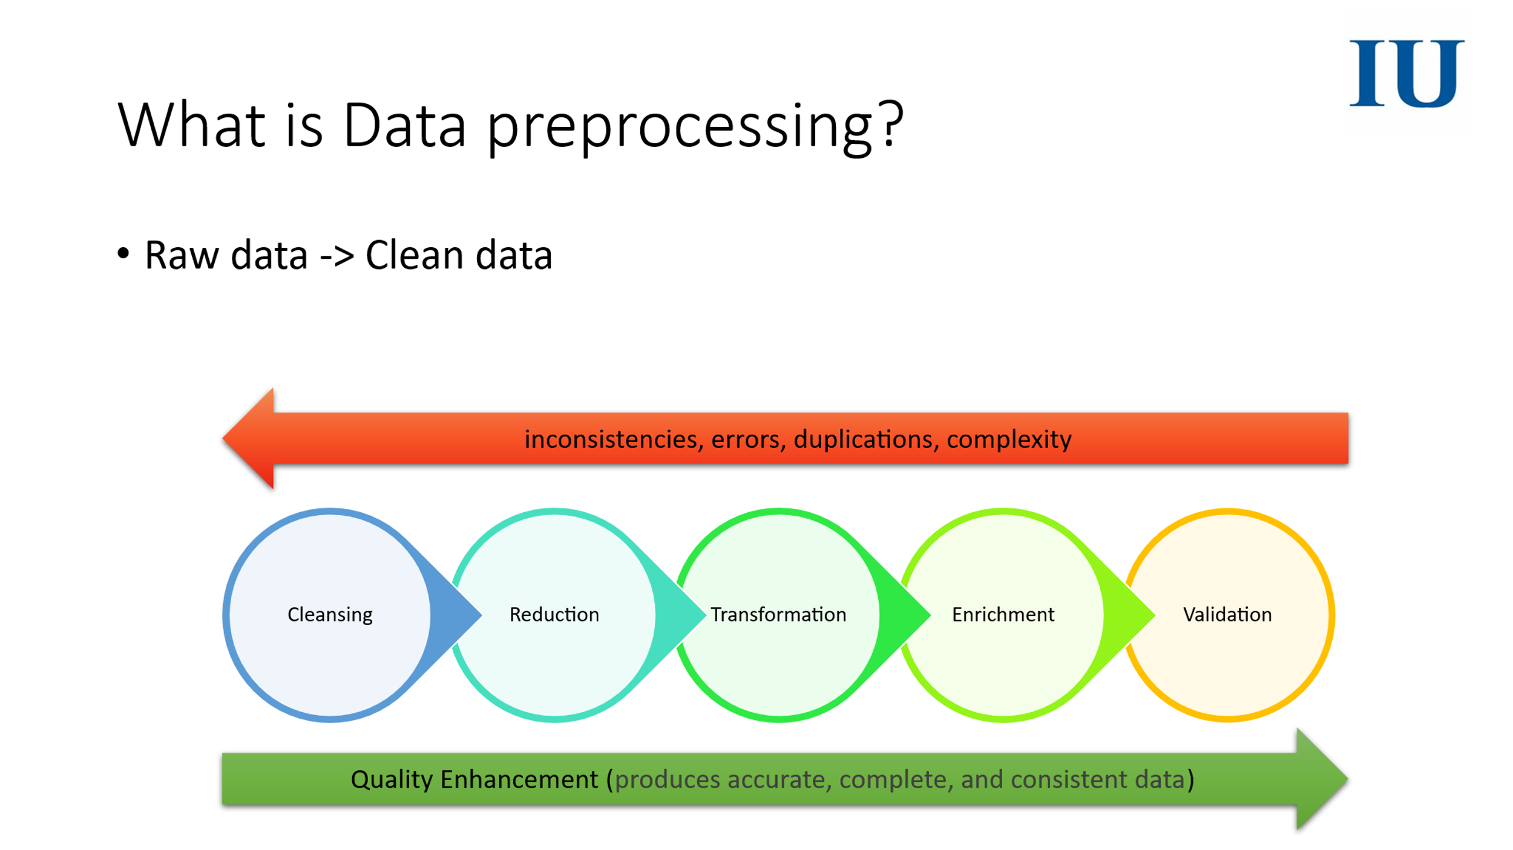

StudentID | Age | TestScore | Subject | Passed
101 | 17 | 85 | Math | Yes
102 | 16 | 79 | Physics | No
103 | 17 | 78 | Math | Yes
104 | 17 | 120 | Math | Yes
104 | 17 | 120 | Math | Yes
105 | 15 | 66 | English | No
106 | 16 | –20 | Physics | No
107 | 18 | 91 | English | Yes
108 | 17 | 88 | Physics | Yes
109 | 19 | 79 | English | Yes

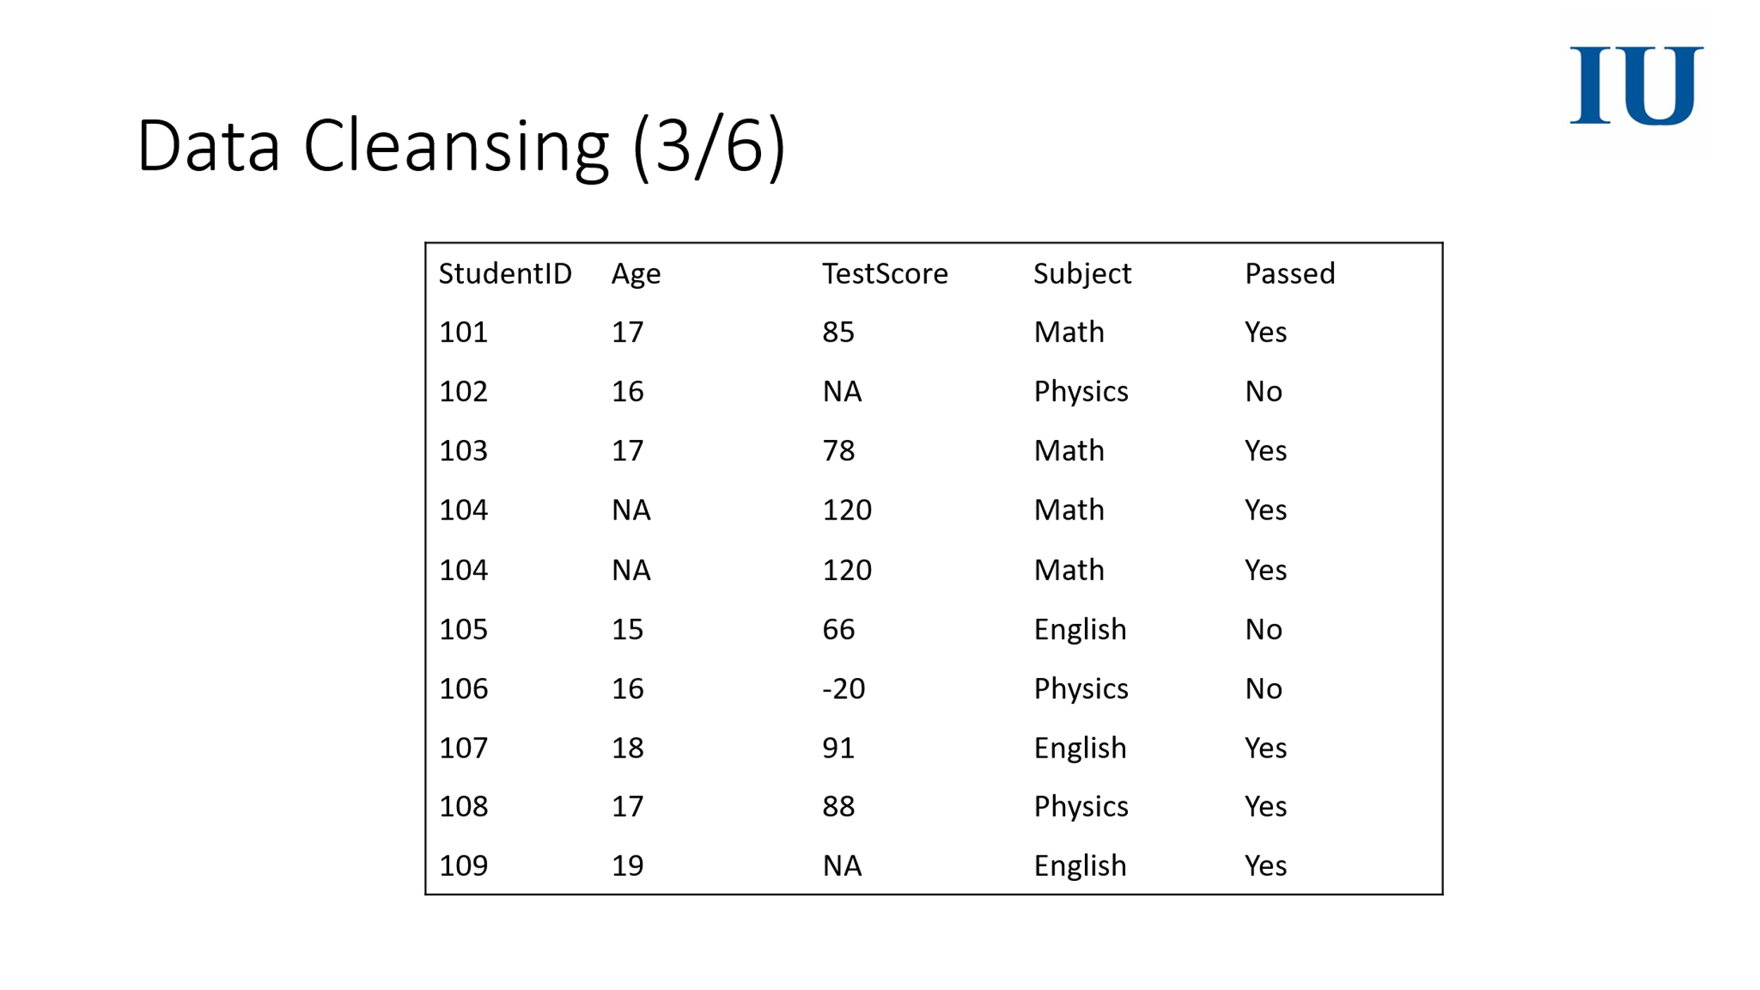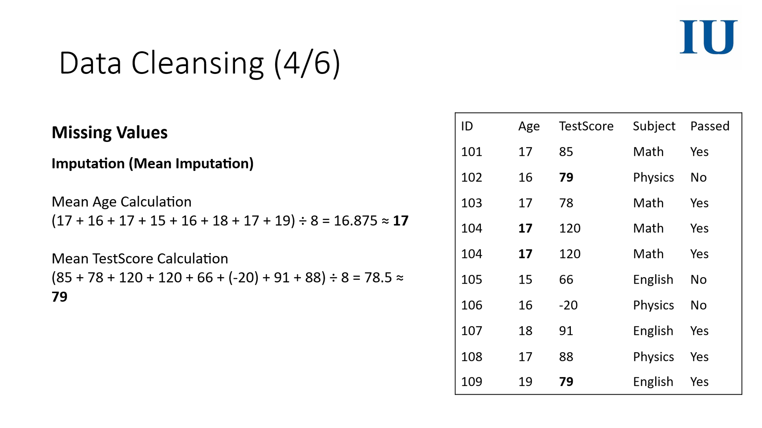

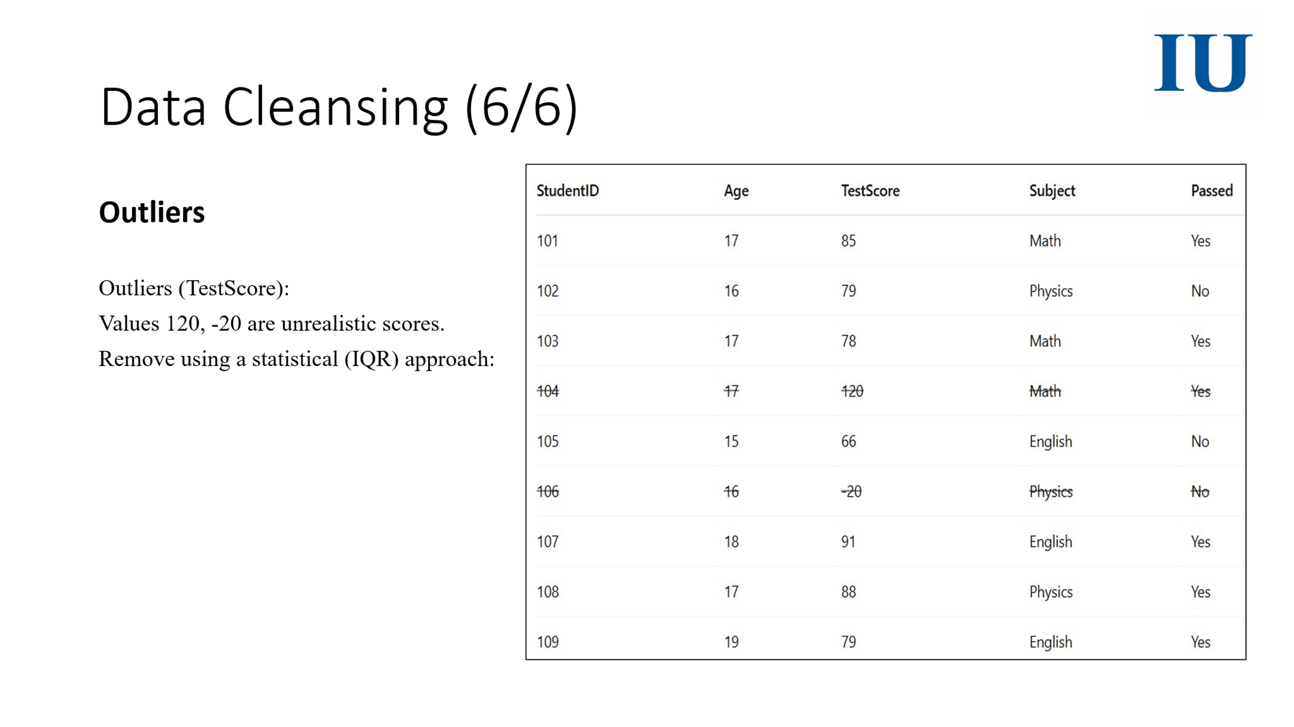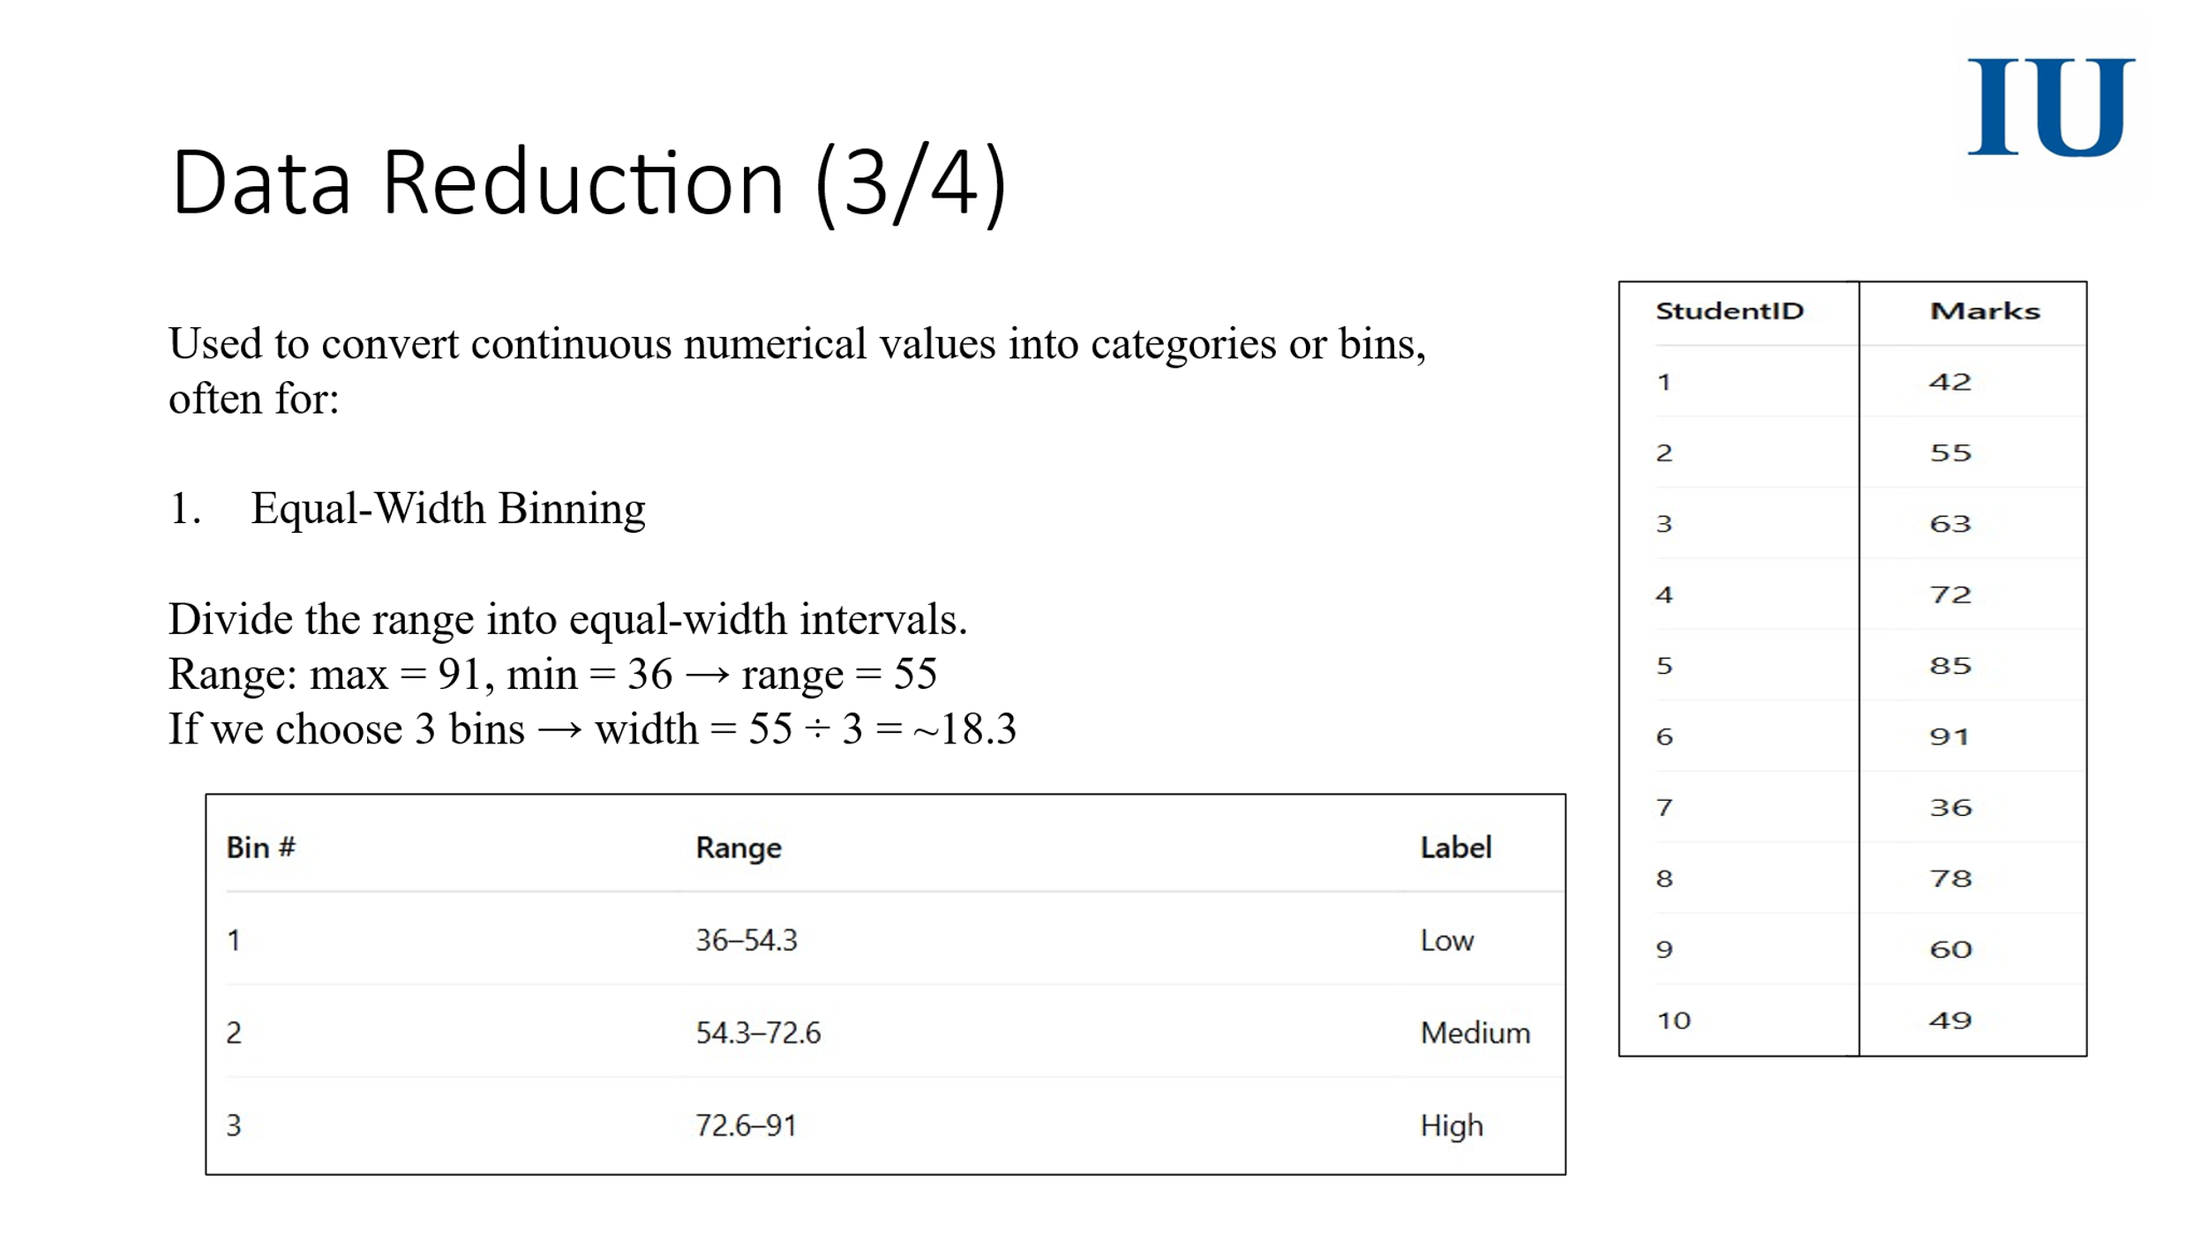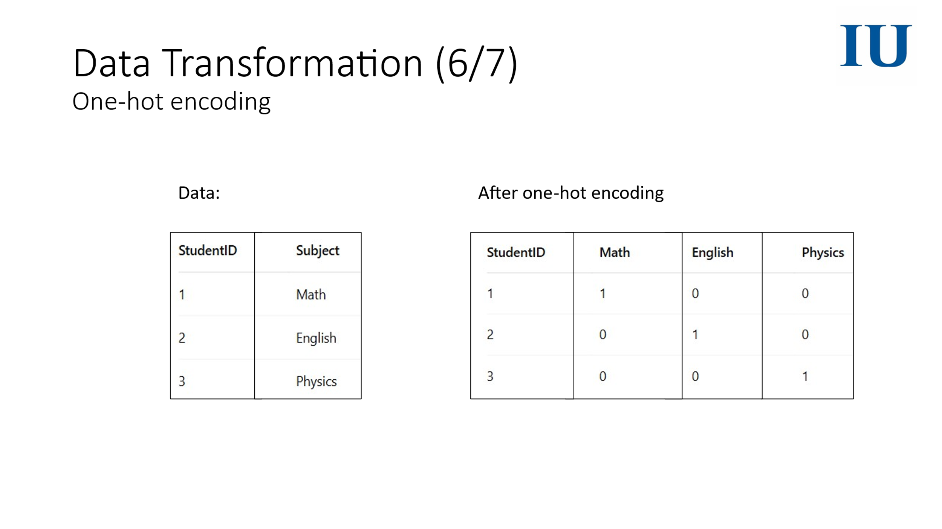

Q3 – Statistical Analysis (Marks 10) — CLO3

What is univariate analysis and what is bivariate analysis? Using the given dataset, calculate the variance and standard deviation of any one numerical feature. Then compute the Pearson correlation coefficient between two numerical features.

Student | Hours_Studied (X) | Exam_Score (Y)
A | 2 | 60
B | 4 | 65
C | 6 | 70
D | 8 | 75
E | 10 | 85

$s^{2}=\frac{∑(x_{i}-\bar{x})^{2}}{n}$, 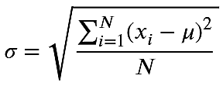

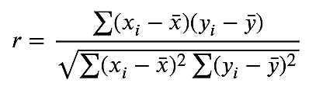

1. What is Univariate Analysis?
Univariate analysis involves analyzing one variable at a time.
Its purpose is to describe the variable and find patterns.
Examples:
- Mean, median, mode
- Variance, standard deviation
- Frequency tables
- Histograms

2. What is Bivariate Analysis?
Bivariate analysis involves analyzing the relationship between two variables.
Examples:
- Correlation
- Covariance
- Scatterplots
- Regression

Dataset
Student | Hours Studied (X) | Exam Score (Y)
A | 2 | 60
B | 4 | 65
C | 6 | 70
D | 8 | 75
E | 10 | 85

3. Variance & Standard Deviation of One Feature
We will use Hours Studied (X).

Step 1: Mean of X
$$\overset{ˉ}{X}=\frac{2+4+6+8+10}{5} \\ \overset{ˉ}{X}=\frac{30}{5}=6$$

Step 2: Variance (Population variance)
Formula:
$$σ^{2}=\frac{∑(X_{i}-\overset{ˉ}{X})^{2}}{N}$$
X | X − 6 | (X − 6)²
2 | -4 | 16
4 | -2 | 4
6 | 0 | 0
8 | 2 | 4
10 | 4 | 16
$$σ^{2}=\frac{16+4+0+4+16}{5} \\ σ^{2}=\frac{40}{5}=8$$

Variance = 8

Step 3: Standard Deviation
$$σ=\sqrt{8}≈2.828$$

Standard Deviation ≈ 2.83

4. Pearson Correlation Coefficient Between X and Y
Formula:
$$r=\frac{∑(X-\overset{ˉ}{X})(Y-\overset{ˉ}{Y})}{\sqrt{∑(X-\overset{ˉ}{X})^{2}∑(Y-\overset{ˉ}{Y})^{2}}}$$

Step 1: Mean of Y
$$\overset{ˉ}{Y}=\frac{60+65+70+75+85}{5} \\ \overset{ˉ}{Y}=\frac{355}{5}=71$$

Step 2: Compute deviations and product
X | X−6 | Y | Y−71 | (X−6)(Y−71) | (X−6)² | (Y−71)²
2 | -4 | 60 | -11 | 44 | 16 | 121
4 | -2 | 65 | -6 | 12 | 4 | 36
6 | 0 | 70 | -1 | 0 | 0 | 1
8 | 2 | 75 | 4 | 8 | 4 | 16
10 | 4 | 85 | 14 | 56 | 16 | 196

Step 3: Summations
$$∑(X-\overset{ˉ}{X})(Y-\overset{ˉ}{Y})=44+12+0+8+56=120 \\ ∑(X-\overset{ˉ}{X})^{2}=40 \\ ∑(Y-\overset{ˉ}{Y})^{2}=370$$

Step 4: Plug into formula
$$r=\frac{120}{\sqrt{40×370}} \\ r=\frac{120}{\sqrt{14800}} \\ r=\frac{120}{121.65} \\ r≈0.986$$

